As a student at Union College, I am part of a community that values intellectual effort, curiosity and discovery. I understand that in order to truly claim my educational and academic achievements, I am obligated to act with academic integrity. Therefore, I affirm that I carried out the work on this exam with full academic honesty, and I rely on my fellow students to do the same.

For this Exam, I understand that:

1. I **must** work alone in writing out the solutions to the problems in this exam.
2. I **cannot** copy solutions, in part or whole, to the problem on this exam from any person or resource.
3. I **cannot** use any electronic resources to assist me in the solution to the questions on this exam except for my calculator to only performing appropriate calculations on the exam.
4. I **can** use one page - single sided - of notes during the exam. This one page of notes **cannot** contain any solutions to problems. **I must staple this page to the back of my exam at the end of the exam**.

Signature:

Print Name:

Exam Date:

**PROBLEM 1:** Answer the following questions for the beam shown below.











**1a.** Determine the reactions at A and D, and using the provided beam bending tables determine the deflections at B andC. Identify and Illustrate the beams used in the solution on the figure provided below.



**1b.** Write a general expression for the load, shear, bending moment, curvature, and deflection of the beam using singularity functions. Make sure to calculate all constants.

**PROBLEM 2:** The beam below is constructed from four boards nailed together at B and C. This board is subjected to a shear of V=850 kN as shown.



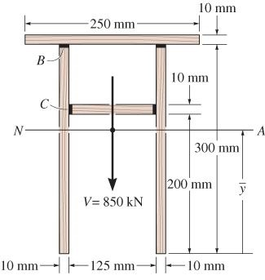

**2b:** Calculate the shear flow through B and C.

**2c:** If each nail can carry 5 kN, what nail spacing is needed at B and C.

